[Insert business logo here]

[Insert business name here]
Travel Plan

Produced by:

[Travel Plan Coordinator name]
[Business address]
[Travel Plan Coordinator email]
[Travel Plan Coordinator telephone]



In association with:


Table of Contents
1. Introduction 1
Motivations 1
2. Site Audit 2
Location 2
Walking & Cycling 2
Public transport 2
Car 2
3. Staff travel survey 3
Headline stats 3
Commuting to work 3
Impact on Travel Plan 3
4. Action Plan 4
Objective 4
Targets 4
Action Plan 4
5. Monitoring and evaulation 5
6. Contact details 6

List of Tables
Table 3-1: 12 month action travel action plan 4
Table 4-1: Travel Plan coordinator details 6

List of Figures
No table of figures entries found.

Introduction
Workplace travel plans are a way of encouraging efficient and environmentally friendly methods for business trips and the commute to and from work. They do this by identifying ways to reduce single occupancy car trips to, from and at work by encouraging and promoting the use of car sharing, public transport, walking, cycling and alternative working methods.
This document is the workplace travel plan for:
- Organisation name
- Organisation slogan (if applicable)
- Sector e.g. Consulting, Courier, Education, Government, Health/ Care, Information Technology, Manufacturing, Media & Communications, Non-profit/ charity, Professional & Financial, Retail, Tourism & Leisure, Training and Transport
- Business operations Please provide a brief outline (just a sentence or two) of your organisation’s main operations
- Total number of employees at the site
- Working hours of the site
- Flexible working, home working & shift working (if applicable)

Motivations
[Insert name of organisation] has identified that we would like to change travel behaviour within our organisation to:
- if you have used NCC’s business travel survey refer to question 16
We consider that several alternative modes of travel may be suitable for some of our staff who currently drive to work on their own, including:
- if you have used NCC’s business travel survey refer to question 17
We also think that the following measures/incentives may be suitable to encourage our staff who currently drive to work on their own to change their travel behaviour, including:
- if you have used NCC’s business travel survey refer to question 18
Based on the above we consider that there is a [very high/ high/ neither high nor low/ low/ very low] likelihood of our staff changing their travel behaviour.

Senior management support
Senior management is committed to developing and supporting this travel plan to help meet the targets set out in section 5. A travel plan co-ordinator has been appointed to deliver the actions identified in the travel action plan. Management is also committed to supporting staff to undertake the actions detailed in the travel action plan and activities.
[Please provide examples of financial resources, staff resources/ time in work to undertake travel plan activities]
The travel plan co-ordinator will report the progress of the delivery of the travel plan actions and performance against the targets to [insert name of senior manager at organisation]. The organisation and its management has already demonstrated its commitment to delivering improvements to sustainable travel options, including:
- [Please provide examples] if you have used NCC’s business travel survey refer to question 15
Financial resources
Detail what financial commitment has been made to ensure all activities listed in the Travel Action Plan Table undertaken:
- [Please provide examples of infrastructural measures]
- [Please provide examples of activities]
Communications strategy
We will communicate with our staff, customers and visitors through the following mechanisms:
Staff
- [Please provide examples] E.g. Email / intranet / notice boards in staffing areas/ newsletters etc.
Customers/visitors
- [Please provide examples] E.g. Email/ website/ information boards in reception area etc.
The travel plan co-ordinator will update senior management on the progress of this travel plan, in terms of delivery of actions and against targets, through the following mechanisms:
- [Please provide examples] E.g. Periodic updates – via telephone, email, face-to-face meetings etc.

Site Audit

Location
A map showing the location of our premises is shown below.
- [Please include an aerial map to clearly show the location of the site] (example below)
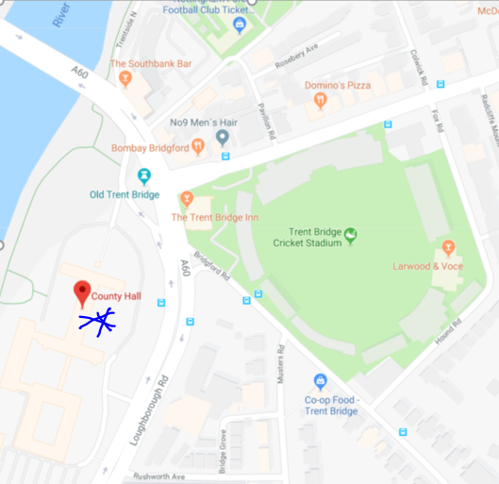
- [Insert text on the local amenities]
Although a traffic survey has not been conducted, we anecdotally note of journey time delays in the area during the morning peak hour (when compared to the inter-peak period) on the following roads:
- [Please provide a list of roads which are known to become frequently congested at peak periods and therefore affect employees traveling to and from site]

Walking & cycling routes
Information relating to the local walking and cycle routes including crossings are listed below.
- [Insert local cycle routes] (if you have used NCC’s site audit form refer to table item 6)
- [Insert local walking routes] (if you have used NCC’s site audit form refer to table item 6)
- [Insert local pedestrian crossings] (if you have used NCC’s site audit form refer to table item 6)

Public transport
Information and maps relating to the nearest bus stops and train stations to the site are stated below.
[Insert text on local bus services and walking distance to the bus stop] (if you have used NCC’s site audit form refer to table item 6)
- E.g. NCT 10 – Ruddington > Nottingham every10 minutes
- E.g. NCT 1 – Clifton > Nottingham every 15 minutes

Map of nearest bus stops shown below.
[Please include an aerial map to clearly show the location of the site and nearby bus stops] (example below)
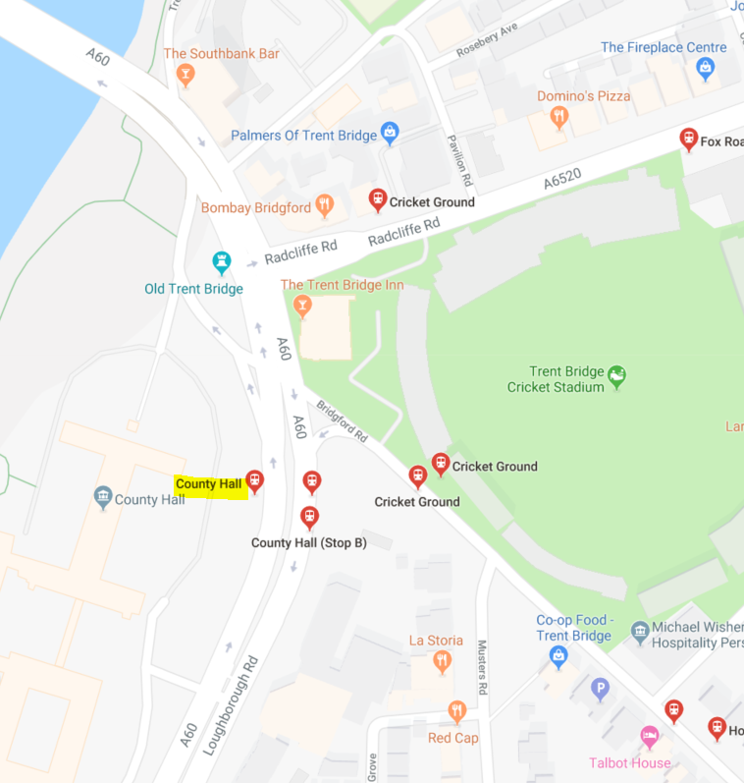

[Insert text on rail services] (if you have used NCC’s site audit form refer to table item 6)
- E.g. the nearest train station is a 1.0-mile walk

Map of nearest train station shown below.
[Please include an aerial map to clearly show the location of the site and nearby train station] (example below)
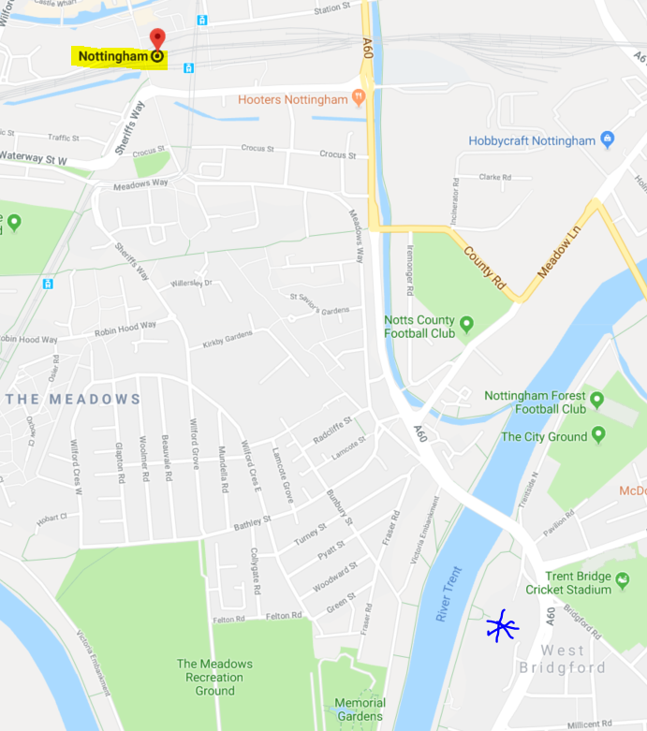

Parking management
On-site parking area restrictions within the organisation’s site parking area
- [Insert list of all restrictions] E.g. Double yellow lines at the site entrance, yellow hatching outside main reception

The organisation has the following number of vehicles in its fleet that are parked on-site:
- [Insert number] of fleet vehicles (car, van, lorry, pool cars, motorbike, pool bike) (if you have used NCC’s site audit form refer to item 7 )

There are also [insert number] of ‘essential’ car users that require to use their cars for work each day

The organisation currently [does/does not] operate a car-share scheme for our employees (if you have used NCC’s business travel survey refer to item 15)

Currently on-site the following parking is provided:
- [Insert number] dedicated staff car park spaces (if you have used NCC’s site audit form refer to item 7)
- [Insert number] dedicated visitor car park spaces (if you have used NCC’s site audit form refer to item 7)
- [Insert number] dedicated pool car parking spaces (if you have used NCC’s site audit form refer to item 7)
- [Insert number] dedicated disabled parking spaces (if you have used NCC’s site audit form refer to item 7)
- [Insert number] dedicated car share parking spaces (if you have used NCC’s site audit form refer to item 7)
- [Insert number] dedicated electric vehicle parking spaces (if you have used NCC’s site audit form refer to item 7)
- [Insert number] dedicated motorcycle parking spaces (if you have used NCC’s site audit form refer to item 7)
- [Insert number] dedicated bicycle parking spaces/storage (if you have used NCC’s site audit form refer to item 11)

Changing facilities for staff
Our organisation provides the following amenities for staff who require changing and/or drying facilities:
- [Insert details] (if you have used NCC’s site audit form refer to item 5)

Site access
We have also identified that there are some additional site access issues that occur at certain times, such as:
- [Insert details] (if you have used NCC’s site audit form refer to item 12)

Off-site impacts
The site audit undertaken as part of the development of this plan indicates how much parking is happening off site
- [Insert details] (if you have used NCC’s site audit form refer to item 12)

Staff travel survey
We would recommend using NCC’s ‘Employee travel survey template’.
The results of the staff travel survey are detailed below.
Once you have analysed the results of your staff travel survey, please insert results from excel here
The results of the staff travel survey were also analysed to determine how far staff are currently travelling to work, as shown in the tables below.
Once you have analysed the results of your staff travel survey, please insert results from excel here
The analysis of the staff travel survey in terms of the distances people travel to work and how they currently choose to travel has been used to determine if there is scope for staff to change how they travel to work. The staff travel survey also helps identify what influences the staff’s travel choices and what barriers they currently have to travelling more sustainably to, from and during work. This information has then been used to develop our tailored action plan detailed in section 4 below to specifically address these issues.

Action Plan

Objective
The objective of our travel plan is to minimise single-occupancy car trips by promoting and supporting alternative modes. This will be done by encouraging more staff and visitors to make more sustainable travel choices (e.g. to walk, cycle, bus, train, or car share) for their journey to the site, both for business and commuter journeys.

Action Plan
The following action plan has been prepared to help us implement the measures proposed in the Travel Plan.
Table 4-1: 12-month Travel Action Plan
- [insert Travel Action Plan table] (we would recommend using NCC’s Travel Action Plan as a template)
TARGET | TRAVEL PLAN INITATIVE | RESPONSIBILITY | TIMESCALES

Targets
Performance of the travel plan is judged against indicators or targets and therefore all travel plans must include targets with respect to the number of vehicles travelling to the site and these targets should stem from the measures you have included in the travel plan.
(NB - The targets you include will therefore help you monitor and review the effectiveness of your travel plan. All targets should therefore give a date at which you aim to achieve it; and the targets contained in the travel plan should be SMART – i.e. specific, measurable, achievable, realistic and time-bound).
Key outcome targets
The main aim of a travel plan should be to minimise single-occupancy car trips by promoting and supporting alternative modes. The key target is therefore to:
- Reduce single-occupancy car trips to/from work by [insert X%] (NB - The percentage reduction will depend on how people currently travel to work).

(NB - In addition to the above, a target to reduce the number of work related journeys should normally be included, or if this is not possible you should explain the reasons why this has not been included).

Intermediate outcome targets
To help determine how effective the measures included in the plan have been in delivering the key outcome target above, several supplementary targets related to other modes of transport should also be developed and included, such as:
- [Insert X%] increase in the number of staff walking to/from work (NB – to reflect the measures in your travel plan to promote walking)
- [Insert X%] increase in the number of staff cycling to/from work (NB - to reflect the measures in your travel plan to promote cycling)
- [Insert X%] increase in the number of staff catching public transport to/from work (NB - to reflect the measures in your travel plan to promote public transport)
- [Insert X%] increase in the number of staff car sharing to/from work (NB – to reflect the measures in your travel plan to promote car sharing).

Contributory output indicators
(NB - Whilst the implementation of measures should be reported as part of the monitoring of the travel plan they are not targets. For instance, the delivery of car share spaces by a certain date does not represent achievement of a target as this is a measure which helps deliver targets related to reducing single-occupancy car journeys, or to increase the number of people car sharing).
Monitoring and reporting on the implementation of the measures included within the travel plan helps determine what is working and what is not. This in turn helps target the valuable limited resources available to deliver the aims of, and targets contained within, the travel plan. Targets are not normally set for the output indicators below as these will only be used to monitor trends, but the current levels should be included for reference and to use as a base year:
(N.B - delete below statements as appropriate)
- Cycle parking occupancy
- Car share space occupancy
- No. of car share registered members
- No. of travel Choice information board in staff areas
- No. of Travel Choice travel packs provided to employees
- No. of Travel Choice travel clinics delivered
- No. of employees who received personalised travel advice at workplace travel clinic
- No. of taster bus tickets given to employees
- No. of taster bus tickets redeemed
- No. of employees who received Dr Bike bicycle maintenance
- No. of employees who have received cycle training
- No. of employees who participated in led cycle rides
- No. of cycle champions
- No. of employees who participated in led walks
- No. of walking champions
- No. of employees who participated in a workplace challenge
- No. of employees who have received a workplace wellbeing check
- Details of Travel Choice grant towards sustainable transport improvements

Monitoring and evaluation
The targets in Table 4-1 will be monitored in partnership by [insert name of travel plan coordinator] and Nottinghamshire County Council in order to track the progress of the Travel Plan in achieving its objectives. The monitoring activities will include an annual staff travel survey.
The Travel Plan itself should be a ‘living’ document. As such, the organisation should give a commitment to review periodically. Given this, a commitment to produce an annual monitoring report.

The results of the surveys undertaken should be periodically circulated to all members of staff and visitors. It should also include any relevant information on changes of personnel, partnerships with organisations and detail of brief plans for the forthcoming year.

It is important that the targets set in the Travel Plan are met. As such, Travel Plans should consider how they would respond if monitoring procedures identified that the organisation was not approaching their agreed targets via the development of an appropriate strategy.

Although mode-split data (percentage of travellers using a particular type of transportation or number of trips using said type) should not form the basis of targets, resultant mode-splits should be reported (in terms of proportions of total trips and quantities) as part of the monitoring reports.

Measures implemented as part of the Travel Plan should also be subject to ongoing monitoring as part of the Travel Plan.

Contact details
Further details regarding this Travel Plan can be obtained from the Travel Plan coordinator:
Table 6-1: Travel Plan coordinator details
Full name | [Insert details]
Telephone number/s | [Insert details]
Email address | [Insert details]

