**Hagg Farm Visit Planning Pack**

Welcome to the Visit Planning Pack for Hagg Farm. The pack contains practical information about the centre, its resources and domestic arrangements to assist you in planning your visit. Please feel free to copy any of the sheets to distribute to your staff team, parents and young people as appropriate.

We have been inspected and licensed by AALS (Adventure Activities Licensing Service), which means we have been judged to have high safety standards. The Hagg Farm Safety Codes of Practice booklet lists all emergency procedures and telephone contacts, and has guidelines for each activity (appropriate equipment, group size and safety). Please read through it before your visit and always have it available during your stay.

Hagg Farm Outdoor Education Centre offers unique opportunities for both young people and staff in an area of tremendous natural beauty.

I am sure that you will enjoy your stay. Please don’t hesitate to contact the centre if you need further information or guidance prior to your visit.



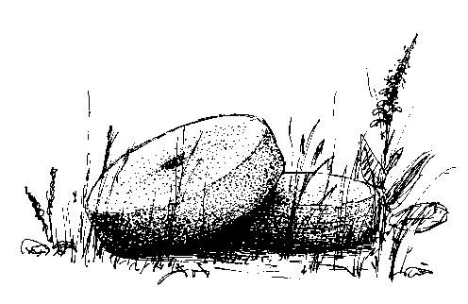Head of Centre

**Contents**

|  |  |
| --- | --- |
| **Section 1: General Forms and Useful Information**  Address and location of Hagg Farm  How to find Hagg Farm  Plan of Hagg Farm  Useful contacts  An Outdoor Educational Experience at Hagg Farm  Things you need to know to plan your visit  Gaining Approval for your visit  Leader’s Checklist  Hagg Farm Planning Sheet  What to bring to Hagg Farm  A typical day at Hagg Farm  Hagg Farm Duty Rota  Hagg Farm Dormitory Competition  Catering  Dormitory/Boot list  Outdoor Equipment (Safety and Field Study)  Games and Entertainment (indoor/outdoor games, TV, DVD etc)  Library information, activity folders and publications  **Section 2: The John Hunt Base**  Introduction and Introductory talk notes  Plan of the John Hunt Base  Useful information  Dormitory/Boot list | **Page**  5  6  7  8  9  10  11  12  13  14  15  16  17  18  19  20  21  22    23  24  25  26 |

**Address and location of Hagg Farm**

Hagg Farm Outdoor Education Centre

Snake Road, Bamford, Hope Valley S33 0BJ

Telephone: 01433 651594

Fax: 01433 651525 (pay phone out of office hours and

contact number for parents out of office hours)

Email: [haggfarm@nottscc.gov.uk](mailto:haggfarm@nottscc.gov.uk)

Website: <www.nottinghamshire.gov.uk/nottsoutdoors/schools-and-groups/centres/hagg-farm>

Hagg Farm is situated in the Upper Derwent Valley of the Peak District National Park,   
off the A57 Snake Road between Ladybower Reservoir and Snake Pass. The map   
shows Nottinghamshire and its relation to the Peak District.

Location map

**How to find Hagg Farm**

About three miles after Ladybower Reservoir, turn right up a steep, sharp-angled driveway. There are white signs for Hagg Farm Centre at the base of the drive and 200 yards before it – you’ll need to slow down! Don’t rely on Sat Nav as the postcode covers about 10 square miles!

To reach us by coach it will take approximately:

Nottingham City 1.5 hours

Mansfield 1.25 hours

Newark 2 hours

North Notts 1.5 hours

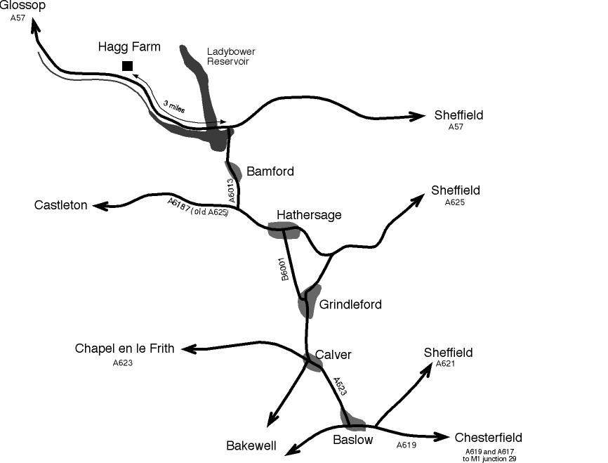

**Plan of Hagg Farm**

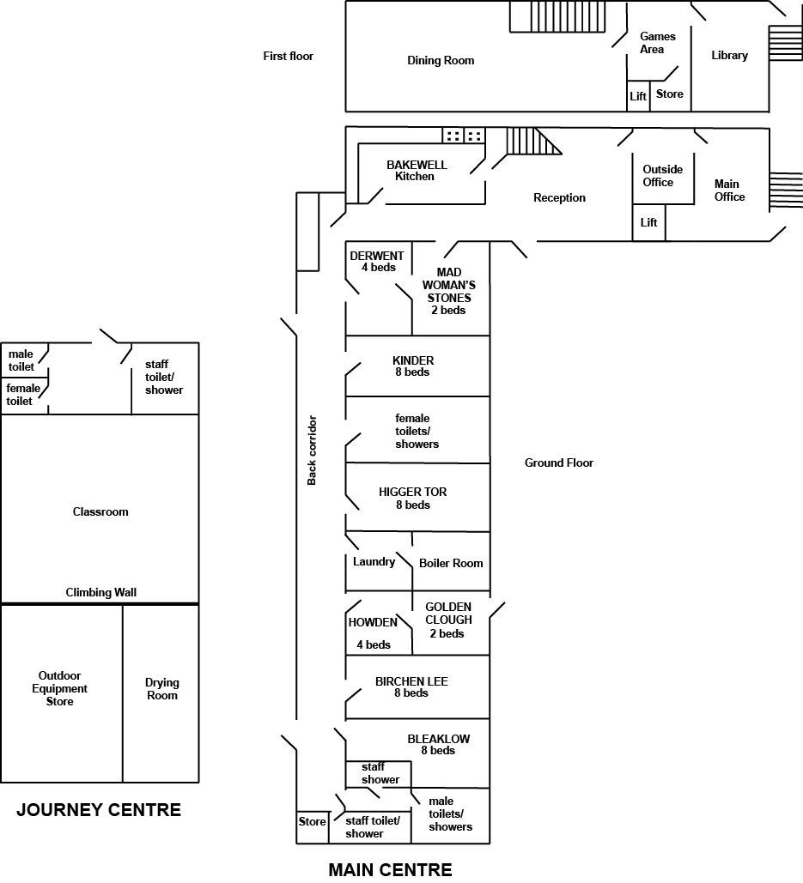

Separate from the main building is The Journey Centre, which incorporates a classroom, the drying room and the equipment store. There are also accessible toilets in this block.

The John Hunt Base, a self-contained annexe to accommodate up to 18 people is also part of the site.

**Useful contacts**

You will be left emergency contact numbers for Hagg Farm staff on arrival. In addition, you may find the following numbers useful.

**Police**

**101** non emergency

**999** in emergency

Chapel-en-le-Frith Police Station (are our contact even though Glossop is nearest)

**Medical**

Evelyn Medical Centre, Hope: 01433 621557

Sheffield Children’s Hospital (under 14): 01142 761111

Northern General Sheffield: 01142 434343

Dentist, Bamford: 01433 651270

Chemist, Hathersage: 01433 650325 (Closed 1 – 2pm.)

**Local suppliers**

Butcher: D Bowyer, Hathersage

Convenience store, Hathersage - open 6am-10pm daily

Sicklehome garage/shop - open 24 hours, at the junction of the main Bamford and Hathersage roads

**Cash available from**

Bamford Post Office (inside the Anglers Rest)

Co-op supermarket in Bradwell

**Other useful numbers**

Fairholmes Tourist Information 01433 659986

Cycle Hire (Fairholmes) 01433 651261

Hathersage outdoor swimming pool (open Mar-Sep) 01433 650843

**Insurance contact**

City schools: 0115 9158158

County schools: 01159 773331

**Coach hire**

Please ensure your coach company knows they must drop groups off in the car park at Hagg Farm. Coaches of 13.5 metres or less can get up the drive and turn around.

* **Coaches must not attempt to turn left into the drive** (from Glossop direction)
* **Coaches must not stop on the main road**.

Please phone for advice in case of difficulty.

**An experience of Outdoor Education at Hagg Farm**

As part of the Outdoor and Environmental Education team, Hagg Farm supports Nottinghamshire County Council schools in planning and providing a balanced and safe programme. The safety guidelines for each activity are given in the Hagg Farm Codes of Practice booklet.

The experience of living and working together at Hagg Farm in itself provides many learning opportunities, although visiting staff are encouraged to use their own experience and subject specialisms to enhance the programme.

All programmes aim to include elements of:

* Field studies
* Outdoor pursuits, safety and survival
* Conservation and service to the environment
* Personal and social education

Hagg Farm can also incorporate a number of educational aims, for example:

* Induction courses and team building, PHSE
* Exam coursework, GCSE and A level sciences, PE, Geography
* Outdoor skills, John Muir Award
* Theme weeks: environment, camp craft, local studies
* Literacy and numeracy

**Activity Sessions led by Hagg Farm Staff**

|  |  |
| --- | --- |
| * Caving * Rock Hopping * Abseiling * Canoeing* (weather dependant) * Stream Scrambling* (weather dependant) | * Indoor Climbing Wall * Jacobs Ladder * Climbing Tower * Zip Wire * Hill Walking * Rock Climbing |

**Activity Sessions that can be led by your staff with our resources**

|  |  |
| --- | --- |
| * Conservation * Local Walks * Environmental Art / Drama * Scavenger Hunts * Shelter Building * Night Line * Night Walks * Woodland / Pond / River Investigations | * Search and Rescue * Orienteering * Problem Solving * Peephole Trail * Animal Trail * Geocaching * Cycling (bikes can be hired from Fairholmes Visitor Centre in the Upper Derwent Valley) |

**Things you need to know to plan your visit**

**Staffing**

* Generally, you need at least one member of staff per 12 pupils.
* Agree the staffing EARLY
* The leader must have attended the ‘Induction to Hagg Farm’ INSET course
* **All staff intending to lead activities off site** must have a basic first aid certificate.
* It is advisable to have a deputy leader in case of illness of the leader

**Transport**

* Book a coach EARLY - remember it must be 12 metres or less to get up the drive and MUST come up the drive for safety reasons.
* Your booking includes use of the Hagg Farm minibus, but you may wish to borrow or hire another.
* It is essential to have a staff car on-site in case transport needed overnight when Hagg Farm staff are not on-site.
* In any event it is useful to have at least one staff car on site

**Paperwork**

You will need full sets of:

* + Payment cards for pupils
  + Parental consent forms along with medical details and emergency contact details for all visitors(EV4 for Nottinghamshire LA schools)
  + Letter(s) to parents
  + Information sheet for parents and carers
  + Kit list for students
  + Final details for pupils
  + Pupils’ record/diary sheets
  + Certificates (optional)

**Staff Team**

During your visit, there are several areas of responsibility for staff teams. Share them between staff according to strengths and experience:

* + Liaison with Hagg Farm staff
  + Collecting safety briefs and equip. for school led activities
  + Meals – liaise with cook
  + First Aid - Pupils’ medication
  + Organising the duty rotas
  + Dormitory checks
  + Evening activities

Plan for short staff briefings - communication is not always easy when there is so much going on.

|  |
| --- |
| **Gaining approval for your visit to Hagg Farm** |
| Your school’s Educational Visit Co-ordinator (EVC) should be aware of the procedures and offer advice on what you will need to do to get approval for your visit. Any visit that is residential and involves adventure activities requires approval from the Local Authority. However as the centre is part of the LA provision your Head teacher has delegated rights to provide approval for trips to Hagg Farm, the visit just needs to be entered on the EVOLVE system as normal (your EVC will help with this).  When planning your visit you should refer to the LA generic risk assessments (available on the EVOLVE system) to check that you have everything in place. For Hagg Farm these will be: 1 (all visits), 2 (travel), 3 (accommodation). You do not need to ask Hagg Farm to provide any additional assurances such as an EV2 form as it is part of the LA’s provision. In order to comply with the Visits Guidance provided by the LA you need to ensure that the relevant control measures indicated within the generic risk assessments are followed and that a school specific risk assessment is in place.      Your specific risk assessment should consider the needs of your group (any special needs?), your journey to the centre (any visits en route?) and any specific ways you will operate. E.g. you may have a child with an allergy which might require additional consideration such as medication being carried at all times, special diet etc. You will need to risk assess anything you do which is not a normal part of a Hagg Farm programme.  You do not need to risk assess the activities provided at Hagg Farm.  All activities at the centre are risk assessed and copies are available  on the web:  www.nottinghamshire.gov.uk/nottsoutdoors/schools-and-groups/centres/hagg-farm  girl walking |

**Leader’s Checklist**

|  |  |  |
| --- | --- | --- |
| **Time-scale** | **Task** | **Done** |
| **As soon as possible:** | * Discuss with senior management team/Educational Visit Coordinator (EVC) * Refer to LA’s Educational Visits Policy * Booking form dates confirmed. Dates on school calendar * Staffing agreed, first aid/induction courses booked if necessary * Delegate planning tasks between staff team * Book coach and/or minibus * Copy admin forms |  |
| **4 to 6 months before visit:** | * Pupil recruitment launch (Hagg Farm promotional leaflet/DVD) * Letter for parents * Arrange payment system * Meeting with Hagg Farm staff |  |
| **4 weeks before visit** | * Gain approval for educational visit from LA. (EVOLVE system) * Meeting with parents, Meeting with your staff team * Arrange insurance if necessary - Check if your school has cover for all visits * If self-catering - plan menus (check special diets) and arrange shopping |  |
| **2 weeks before visit** | * Sort out dormitory groupings * Organise activity groups (up to 12 in each) and duty groups * All money collected in * All medical forms in, copy to your Head teacher * Check coach booking * Agree staff responsibility areas, invite other staff to visit * Dormitory/boot size list to Hagg Farm * Information on special dietary needs sent to Hagg Farm * Inform Hagg Farm of any medical or behavioural issues |  |
| **Last week before visit** | * Sort staff travel arrangements (maps) * Final details to pupils (travel times, packed lunch on 1st day, medication) * Buy food if self-catering * Cash available for expenses during the visit * Sick bags and medical forms in coach |  |
| **Parents’ meeting** | Meet parents about 4 weeks ahead to explain   * The purpose of the visit * Hagg Farm facilities, the programme and activities, what to pack and travel arrangements * insurance, medical and contact details * Give parents and guardians an opportunity to discuss any concerns they have - highlight any issues that might affect their child’s participation in an outdoor activity residential experience * Behaviour requirements and procedures if child needs to return home * Make parents and the school office aware there is no reliable mobile phone signal – but give an emergency contact number for the Hagg Farm office or mobile number if one of your visiting staff is on Vodafone, O2 or Tesco networks. |  |

**Planning Sheet**

|  |  |  |  |  |
| --- | --- | --- | --- | --- |
|  | **Task** | **Completion date** | **Completed** | **Name** |
|  | Discuss with SMT/EVC. Decide course focus |  |  |  |
|  | Book centre |  |  |  |
|  | Dates on calendar |  |  |  |
|  | Agree staffing |  |  |  |
|  | Check staff qualifications/experience |  |  |  |
|  | Book coach |  |  |  |
|  | Identify staff responsibilities – payments, food coordinator etc |  |  |  |
|  | Print initial letters |  |  |  |
|  | Launch recruitment and distribute letters |  |  |  |
|  | Paying in sheets |  |  |  |
|  | Meeting with Hagg Farm staff |  |  |  |
|  | Print pupil diaries |  |  |  |
|  | Print staff guides |  |  |  |
|  |  |  |  |  |
| **4 weeks to go** | Parents’ meeting |  |  |  |
|  | EVOLVE request |  |  |  |
|  | Dormitory/activity/duty groups |  |  |  |
|  | Balances to collect |  |  |  |
|  |  |  |  |  |
| **2 weeks to go** | Confirm coach |  |  |  |
|  | Check insurance |  |  |  |
|  | Dietary requirements to Hagg Farm |  |  |  |
|  | Dormitory list to Hagg Farm |  |  |  |
|  | Invite SMT/Governors |  |  |  |
|  | Preparation with pupils |  |  |  |
|  |  |  |  |  |
| **1 week to go** | Food shopping (if self-catering) |  |  |  |
|  | All consent forms in |  |  |  |
|  |  |  |  |  |
| **On return** | Assembly/display |  |  |  |
|  | Organise reimbursement for free school meals |  |  |  |
|  | Governors’ report/news and views |  |  |  |
|  |  |  |  |  |
| **Remember to take:**   * Medical forms * Food * Sick bags * Litter bags * Your own kit! | | | | |

**What to bring to Hagg Farm**

Hagg Farm provides all specialist clothing and equipment for activities. On arrival, pupils will be issued with walking boots, rucksacks, waterproof jackets and trousers.

All bedding is provided but not towels.

In an active week at Hagg Farm, most people need more clothes than they would normally use at home!

It is useful to label all clothing with pupil names.

**Suggested kit list:**

* Several pairs of socks (thick socks for walking boots not trainer socks)
* Outdoor shoes/trainers
* Indoor shoes/slippers
* Several pairs of trousers suitable for activities, e.g. tracksuit trousers NOT jeans
* Lots of t-shirts
* Several warm jumpers and sweatshirts or fleece tops
* Warm coat or fleece top
* Hat, scarf and gloves
* Wash kit and towel
* Nightwear
* Underwear
* Swimwear (useful if doing gorge walking or canoeing)
* Medicines including inhalers (don’t forget a spare)
* Sun cream and insect repellent in summer
* Torch, camera if you have them
* Pencil case
* Drinks bottle / Flask bottle to use during your stay – please do not bring glass thermos flasks
* *** **Packed lunch for first day** ***

**What not to bring**

**We ask that group members do not bring chewing gum.**

**Please avoid spray deodorants as these can affect those that suffer with asthma and can cause issues with the smoke detectors.** *Roll on / stick deodorants are fine***.**

**You will not need much money, as there are very few opportunities to spend it!**

**Hagg Farm will not take any responsibility for electronic devices/valuables e.g. phones, watches, tablet computers etc.**

**A typical day at Hagg Farm**

|  |  |
| --- | --- |
| **Time** | **What’s happening** |
| 7.00am | Teachers and pupils wake up |
| 7.30am | Duty group lay out for breakfast in dining room |
| 8.00am | Breakfast |
| 8.30am | Clean up after breakfast and get ready for activities |
| 9.00am | Dormitory inspections as part of a competition |
| 9.30 - 12.30pm | Morning activity sessions |
| 12.30 -1.30pm | Packed lunch |
| 1.30 - 4.30pm | Afternoon activities session |
| 4.00pm | Check preparations for evening meal |
| Approx. 5.30pm | Evening meal |
| Approx 7pm | Clean up after evening meal and get ready for activities |
| 7.30pm | Evening activities |
|  | Bed time |

**Arrival**

* On arrival you will unload the coach and drop bags in a central area as requested by Hagg Farm Staff
* The group will then be given a briefing on house rules and fire procedures.Group members will go to rooms, unpack and make beds
* Depending on the time, kit issue of water proofs and boots may be before or after lunch
* There is a quiz to help young people find their way around the centre (if time allows)
* There will usually be a fire drill shortly after your arrival

**Last Night**

The Hagg Farm staff will collect waterproofs and start cleaning boots with the group if equipment is not needed on the final evening

**Last Day**

* The group will be expected to pack bags before breakfast and strip bed linen off
* Eat breakfast
* After breakfast – the group should hoover dining room & stack chairs
* Put luggage in central area ready to load coach
* Hoover bedrooms and empty bins
* Check rucksack and drying room for personal items
* If time allows, groups may want to buy from the gift shop or play games

** Hagg Farm Duty Rota **

|  |  |  |  |  |  |
| --- | --- | --- | --- | --- | --- |
|  | **Day 1** | **Day 2** | **Day 3** | **Day 4** | **Day 5** |
| Breakfast Upstairs |  |  |  |  |  |
| Breakfast Downstairs |  |  |  |  |  |
| Lunch Upstairs |  |  |  |  |  |
| Lunch Downstairs |  |  |  |  |  |
| Eve. Meal Upstairs |  |  |  |  |  |
| Eve. Meal Downstairs |  |  |  |  |  |

** Hagg Farm Dormitory Competition **

|  |  |  |  |  |  |
| --- | --- | --- | --- | --- | --- |
|  | **Day 1** | **Day 2** | **Day 3** | **Day 4** | **Day 5** |
| Derwent (4) |  |  |  |  |  |
| Higger Tor (8) |  |  |  |  |  |
| Kinder (8) |  |  |  |  |  |
| Howden (4) |  |  |  |  |  |
| Birchen Lee (8) |  |  |  |  |  |
| Bleaklow (8) |  |  |  |  |  |

**Catering**

The Additional Support form you have already completed will have captured your preferences for either -

**Option 1 - Cooked Breakfast**

* cooked breakfast, prepared by our staff
* prepared packed lunches
* evening meal prepared for you with instructions for finishing off and serving

or

**Option 2 - Cereal and Toast Breakfast**

* self-served breakfast of cereal and toast
* self-prepared packed lunch
* prepared evening meal for you with instructions for finishing off and serving

**Menu Choices**

Please see the separate menu sheet enclosed with your booking information. You are asked to supply menu choices **no later than 2 weeks** before your visit.

**Allergies and Special Diets**

Our staff can cater for allergies and specialist diets and would be happy to discuss any concerns on a one-to-one basis. Please let us know about allergies as early as possible and at the latest 2 weeks before your visit. Please feel free to phone to speak to our catering staff if you need further help.

**Self-Catering**

The kitchen is well equipped to cater for groups. There are two large gas cookers, toasters, microwave, water boiler, large mixer, freezers, a large fridge and a dishwasher. Kitchen utensils, crockery and tea towels are provided.

Your course tutor will contact you a few weeks before the course to check your menu choices and any dietary requirements.

knife, fork, spoon copy

**Dormitory/Boot List**

**Please fill in names and boot sizes in dormitory groups to allow us to prepare the centre for your visit.**

Group

Day/Dates Arrival Time Departure Time

|  |  |  |  |  |  |  |  |  |  |  |  |  |  |
| --- | --- | --- | --- | --- | --- | --- | --- | --- | --- | --- | --- | --- | --- |
| Name | Boot Size | W/P Top | W/P Bottoms |  | Name | Boot Size | W/P Top | W/P Bottoms |  | Name | Boot Size | W/P Top | W/P Bottoms |
| **MADWOMANS’S STONES (female)** | | | |  | **KINDER (female)** | | | |  | **HIGGER TOR (female)** | | | |
|  |  |  |  |  |  |  |  |  |  |  |  |  |  |
|  |  |  |  |  |  |  |  |  |  |  |  |  |  |
| **DERWENT (female)** | | | |  |  |  |  |  |  |  |  |  |  |
|  |  |  |  |  |  |  |  |  |  |  |  |  |  |
|  |  |  |  |  |  |  |  |  |  |  |  |  |  |
|  |  |  |  |  |  |  |  |  |  |  |  |  |  |
|  |  |  |  |  |  |  |  |  |  |  |  |  |  |
| **HOWDEN (male)** | | | |  |  |  |  |  |  |  |  |  |  |
|  | **BIRCHEN LEE (male)** | | | |  | **BLEAKLOW (male)** | | | |
|  |  |  |  |  |  |  |  |  |  |  |  |  |  |
|  |  |  |  |  |  |  |  |  |  |  |  |  |  |
|  |  |  |  |  |  |  |  |  |  |  |  |  |  |
|  |  |  |  |  |  |  |  |  |  |  |  |  |  |
| **GOLDEN CLOUGH (male)** | | | |  |  |  |  |  |  |  |  |  |  |
|  |  |  |  |  |  |  |  |  |  |
|  |  |  |  |  |  |  |  |  |  |  |  |  |  |
|  |  |  |  |  |  |  |  |  |  |  |  |  |  |

**Please return the completed form to**

**Hagg Farm 14 days prior to your visit.**

**Email:** [**haggfarm@nottscc.gov.uk**](mailto:haggfarm@education.nottscc.gov.uk)

**Fax: 01433 651525**

Number of Staff

**Outdoor Equipment (Safety and Field Study)**

A variety of equipment and resources are available for you to use during your stay including safety and outdoor equipment, games, field study equipment, videos and computer software. Hagg Farm staff will issue some of these for specific activities, but please just ask if there is anything else you would like to use.

**Safety Equipment**

**Teacher Pack Rucksack** – these will be issued to all staff and contain

* First Aid Kit
* Emergency Shelter
* Emergency Contacts Details
* Bivi bag
* Torch
* Spare Hat and Gloves

Flask, water bottles and further spare clothes are also available

**Phones and Radios**

We provide a Vodafone network mobile phone and VHF radios to use in an emergency when on activities.

**Maps**

A range of maps that show walking routes in and around Hagg Farm.

**Camping equipment**

Tents, karrimats, sleeping bags, Trangia stoves.

**Outdoor Protective Clothing**

Waterproofs; wellingtons; walking boots are all provided as appropriate

**Field study equipment**

Hagg Farm has field study equipment suitable for all key stages.

|  |  |
| --- | --- |
| * + Measuring tapes   + Metre rules   + Ranging poles   + Clinometers   + Pond nets and collecting trays   + Sample bottles/containers   + Magnifying lenses   + Pooters (for mini beast hunts) | * + Light meter   + Thermometers   + Anemometer   + Hygrometer   + Microscopes   + Laminated maps   + Stop watches * Clipboards |

**Problem Solving equipment**

A variety of equipment and task briefings are available for outside use.

**Games and Entertainment**

**Outdoor games**

Quick cricket set, rounders, football and giant Jenga are available.

[](http://www.fotosearch.com/CSP055/k0557882/)

**Indoor Games**

Board games

Pool table and equipment

Table football

Problem solving games

Flip charts and data projector

**Art and Craft**

Paper, paints, pens etc. are available in the classroom

**Wifi**

O2 wifi is available in many council buildings and is available for use by visiting staff.

**Hagg Farm entertainment systems**

[](http://www.dreamstime.com/stock-photos-dvd-player-image19722673)Hagg Farm has a television and DVD player

in the dining room for group use.

There is also a TV and DVD in the classroom.

Hagg Farm has a supply of DVDs which you are welcome to borrow.

**Library Information, Activity Resources and Publications**

|  |  |
| --- | --- |
| **Information folders/boxes**  Located in main reception. Dip into these at your leisure!   * Navigation and mapwork * Local history   **Activity resources**  These are located in the small office. Please ask for any you may be interested in using.   * Problem solving * Walks from Hagg Farm * Rock activities * Shelter building * Conservation * Art ideas * Reviewing * Search and rescue * First aid * Orienteering * KS3 geography – Whose land is it anyway? * KS4 & ‘A’ level geography fieldwork * GNVQ – residential experience   **Booklets to take away**  Located in small office   * Problem solving * PSHE & citizenship * Reviewing * Maths challenge * Natural pictures and sculptures | **Curriculum Materials**  These following may be useful when planning your visit, or during your stay. Please feel free to take them away with  you to use back at school.   * Pupil recruitment leaflet * Safety Codes of Practice * Planning a Programme for KS3 pupils * Personal Development Planning for GNVQ Residentials * Field Study Sites * Reviewing * Best Foot Forward (Erosion) * Derwent Valley: Leisure and Life * Derwent Valley: A Well Watered Landscape * Derwent Valley: Conservation and Land Use * PHSE & Citizenship at Hagg Farm * Whose Land is it Anyway? (Land Use Study) * Pond Study * Rock Activities * Search and Rescue * Leisure and Tourism in the Peak District * ‘A’ Level Geography |

Please note: although this list is current at time of print, resources are subject to change.

**The John Hunt Base**

**Introduction**

The John Hunt Base is a self-contained annexe of Hagg Farm sleeping up to 18 people. It offers a variety of educational opportunities for schools and teachers including AS and A level fieldwork, special needs programmes, and staff planning or developmental work.

The booking fee includes the use of field study equipment, boots, waterproofs and rucksacks. Centre staff are available for advice and help with programme planning. We can arrange to buy in qualified staff for specialist adventure activities.

**Introductory Talk Notes**

The aim of the John Hunt Base is to create an informal atmosphere for small groups. A formal introductory talk is unnecessary, but it is essential that certain items are discussed on the first day. These are:

* Fire talk (note the 2 fire exits - front door and in Tenzing dormitory)
* No smoking/drinking/drugs/visiting other dormitories
* Young people are not to enter the main centre
* During free time, stay within John Hunt Base or rear field
* Please follow food hygiene guidance
* Climbing tower, Jacobs Ladder or Zip Wire are for use only with Hagg Farm Staff
* Please use the climbing boulder with care (see signs)
* **The House and Garage are privately owned - Please do not park in front of or enter these buildings**.

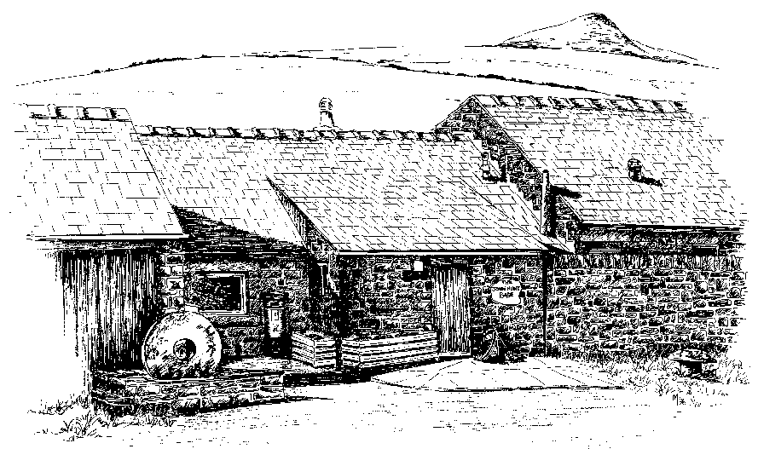

**Plan of the John Hunt Base**

The John Hunt Base has a comfortable lounge/dining area, two shower/toilet areas (one equipped for disabled use), four dormitories and a fully equipped kitchen.

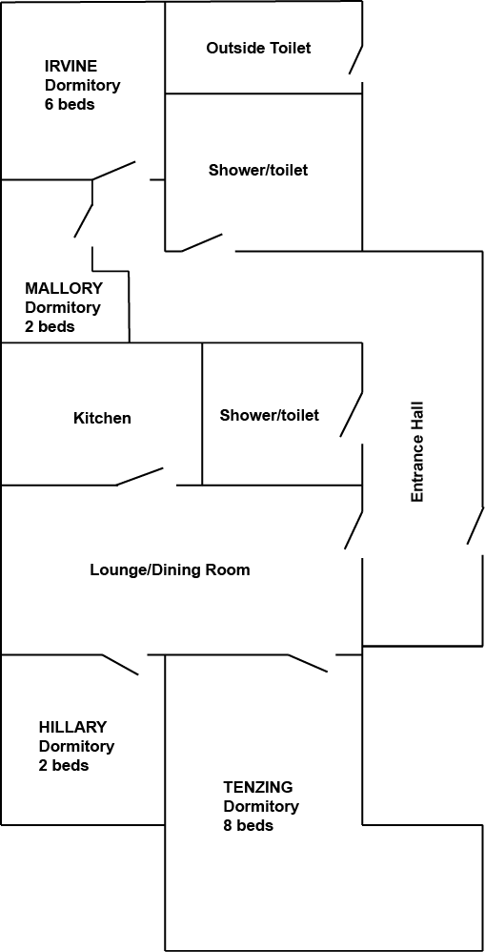

**Useful information**

The pay phone is available for use out of office hours - 01433 651597.

Telephone receiver

The fire alarm system in the John Hunt Base and main centre are linked. The alarms going off in one centre will trigger the alarm in the other. Please evacuate until you have established that there is no fire.

Instructions for use and information about the fire alarm procedure are by the control panel in the corridor.

Hot water and heating controls are in the boiler room, off the corridor.

There is a DVD player and freesat digital TV.

Cleaning materials are available in the kitchen and the

cupboard in the corridor.

Please tidy and clean the Base before you depart.

Please do not leave any food in the fridge.

There is a cardboard recycling cage on the back field near the canoe store. Please flatten all boxes before putting them in there. Please do not use the cage to recycle other items. There are no other recycling facilities on site and it would be appreciated if you could recycle any other materials when you are out and about.

**Kitchen**

The kitchen has a range style electric cooker, kettles, toaster, microwave, fridge and freezer. Cutlery, crockery and cooking utensils for 18 people are provided.

**Extra things to bring**

Most mobile phone networks do not work in and around Hagg Farm with the exception of Vodafone and O2 .

**John Hunt Base Dormitory/Boot List**

**Please fill in names and boot sizes in dormitory groups to allow us to prepare the centre for your visit.**

Group

Day/Dates Arrival Time Departure Time

|  |  |  |  |  |  |  |  |  |  |
| --- | --- | --- | --- | --- | --- | --- | --- | --- | --- |
|  | Name | Boot Size | W/P Top | W/P Bottoms |  | Name | Boot Size | W/P Top | W/P Bottoms |
|  | HILLARY | | | |  | MALLORY | | | |
|  |  |  |  |  |  |  |  |  |  |
|  |  |  |  |  |  |  |  |  |  |
|  | TENZING | | | |  | IRVINE |  |  |  |
|  |  |  |  |  |  |  |  |  |  |
|  |  |  |  |  |  |  |  |  |  |
|  |  |  |  |  |  |  |  |  |  |
|  |  |  |  |  |  |  |  |  |  |
|  |  |  |  |  |  |  |  |  |  |
|  |  |  |  |  |  |  |  |  |  |
|  |  |  |  |  |  |  |  |  |  |
|  |  |  |  |  |  |  |  |  |  |



**Please return the completed form to**

**Hagg Farm 14 days prior to your visit.**

**Email:** [**haggfarm@nottscc.gov.uk**](mailto:haggfarm@education.nottscc.gov.uk)

**Fax: 01433 651525**