What to bring to Hagg Farm

Hagg Farm provides all specialist clothing and equipment for activities. On arrival, pupils will be issued with walking boots, rucksacks, waterproof jackets and trousers.

All bedding is provided.

In an active week at Hagg Farm, most people need more clothes than they would normally use at home!

It is useful to name all clothing.

Suggested kit list:

Several pairs of socks (thick socks for walking boots not trainer socks)
Outdoor shoes/trainers
Indoor shoes/slippers
Several pairs of trousers suitable for activities, e.g. tracksuit trousers NOT jeans
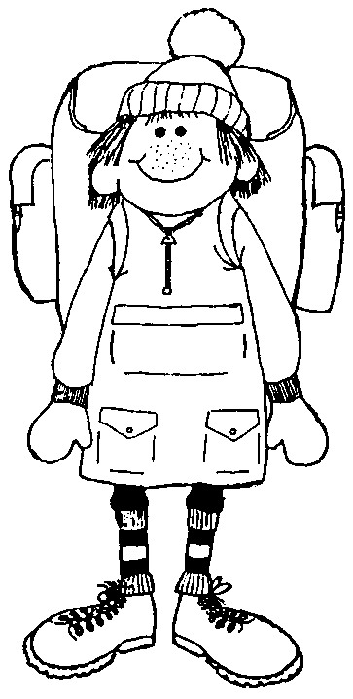
Lots of t-shirts
Several warm jumpers and sweatshirts or fleece tops
Warm coat or fleece top
Hat, scarf and gloves
Wash kit and towel
Nightwear
Underwear
Swimwear (useful if doing gorge walking or canoeing)
Medicines including inhalers (don’t forget a spare)
Sun cream and insect repellent in summer
Torch, camera if you have them
Pencil case
*** Packed lunch for first day ***
Drinks Bottle / empty pop bottle to use during your stay
Unbreakable flasks only - Please do not bring glass thermos flasks

What not to bring

We ask that group members do not bring chewing gum.

Please avoid spray deodorants as these can affect those that suffer with asthma and can cause issues with the smoke detectors. Roll on / stick deodorants are fine.

You will not need much money, as there are very few opportunities to spend it!

Hagg Farm will not take any responsibility for valuables you bring e.g. phones, watches, cameras, iPods etc.

