2023

Safety Codes of Practice
Perlethorpe Environmental Education Centre

Author: Keith Rider
Release Date: 01.06.2023
Review Date: 31.05.2024

Emergency Contacts

Your School:
Telephone Number(s):
Perlethorpe Environmental Education Centre: 01623822218

Keith Rider, Perlethorpe Environmental Education Centre,
Perlethorpe, Newark, Notts NG22 9EQ
Telephone: 01623 822218

Nottinghamshire LA Outdoor Education Adviser
01623 556110

Nottinghamshire LA Emergency Helpline

In the event of an ‘after hours’ emergency,
when no support staff are available:
0300 456 4546

If the situation is life threatening, immediately ring:
999
(Centre addresses are above)

Contents

Emergency Contacts 2

Introduction 4

Health and Safety Policy Statement 5

Safety Responsibilities of Outdoor and Environmental Education team 6

Safety Responsibilities of Visiting Schools 7

General Information about the Centres 8

Perlethorpe Environmental Education Centre 10

Safety Procedures at the Centres – notes for leaders 13

Activity Codes of Practice 16

Activities 20

Introduction

This booklet is aimed at providing all the necessary practical information required for groups visiting the Environmental Education Day Centre at Perlethorpe. The Environmental Education Day Centres are maintained by Nottinghamshire County Council Local Authority (LA) for schools. Safety at the centres is managed by the Council’s Outdoor and Environmental Education team.

By describing the standards of safety provided for schools by the Outdoor and Environmental Education team (OEE Team) and standards which visiting schools are recommended to provide for their pupils, it provides a quality assurance document for governors, headteachers, teachers, parents and pupils alike.

Because the safety of visiting one of the centres is the joint responsibility of the OEE Team and the visiting school and other agencies responsible for the management of the site, this document makes clear the responsibilities of and provides codes of practice for all groups of staff. All support staff, visiting teachers and leaders should have access to, and be familiar with, these codes of practice.

The document follows the recommendations and requirements of Nottinghamshire LA’s ‘Visits Guidance for Children and Young People’. Schools from other LAs should also follow their own LA’s policies in planning and undertaking their visit. Private schools should have their own policy.

The risk assessments for all activities carried out at the centre is available on the internet at www.nottinghamshire.gov.uk/nottsoutdoors and (for Nottinghamshire schools) on the Schools Portal website.

In following this booklet, all concerned need to appreciate that no document of this nature can cover every possible set of circumstances. Safe educational experiences ultimately rely on the common sense and good judgement of teachers and other adults, while working within their own experience and capabilities.

The Environmental Education
Day Centres

Health & Safety Policy Statement

The Outdoor and Environmental Education staff managing the day centres recognise their responsibility for giving effect to Nottinghamshire County Council’s safety policies for the protection of all centre staff, pupils, visiting teachers and members of the public liable to be affected by the operations and activities of the centres.

Within the line management structure of Children, Families and Cultural Services, the Head of Centre or tutor based at the centre will manage the health and safety functions of the centre to prevent, so far as is reasonably practicable, injuries to any person as a result of the operation of the centre by provision of safe premises and equipment, and the effective management of the work activities over which the centre exercises control. This provision will be based on the principles of risk
management and include any controls and protective equipment necessary for persons identified as being at risk.

The Head of Centre/centre tutor will, so far as is reasonable to do so, ensure that staff designated with health and safety responsibilities are competent to carry these out. It is the duty of all centre and visiting staff to co-operate with the Head of Centre/centre tutor to ensure the safety of themselves, co-employees, pupils and other persons liable to be affected by their activities at work and to follow the operational procedures of the centre.
Signed:

Keith Rider
Position: Senior Tutor,
Perlethorpe Environmental Education Centre
Date: June 2023

Signed: 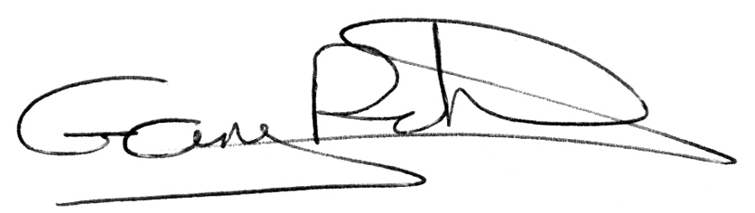

Gary Richards
Position: Team Manager

Safety Responsibilities

Safety responsibilities of the
Outdoor and Environmental Education Team

In liaison with the Thoresby Estate at Perlethorpe, the Head of Centre/centre tutor will:

• take overall responsibility for the management of health and safety of all areas in their operational control.

• through the proper processes of risk assessment, ensure appropriate standards of health and safety in classrooms and other areas under their management, including, where appropriate, the building, furniture and fittings, water, sewerage and other services, fire precautions and procedures, following, as appropriate, local authority fire, environmental health and general safety advice.

• liaise with site managers of Thoresby Estate at Perlethorpe to ensure any areas of potential risk to visiting schools are identified and appropriate measures taken.

• undertake risk assessments and provide written guidelines/codes of practice to schools for activities undertaken in or from the centre.

• provide pre-visit training for visiting leaders through structured meeting.

• conduct a pre-visit planning process with visiting staff in order to agree a safe and appropriate programme.

• take responsibility, where appropriate, for the overall management and safety of pupils both on and off-site, including, as necessary, making decisions in relation to the management of activities and the amendment or cancellation of activities.

• provide first aid equipment and materials, written guidance as to procedures to be followed in an emergency and, wherever possible, leadership and management of emergency situations.

• ensure that the centres’ outdoor clothing, equipment and teaching equipment is safe and suitable.

• ensure that any catering equipment and provision complies with the local Environmental Health Officer’s recommendations.

• undertake supervision and leadership of pupils where so agreed in a programme.

• ensure all Service staff leading activities are sufficiently experienced, trained and qualified in accordance with the centres’ codes of practice.
Safety Responsibilities
of Visiting Schools

Through the management of the teacher leading the visit, the visiting school is responsible for:

• ensuring that all adults in charge of groups working independently are fully briefed by the visit leader in relevant aspects of health and safety including; fire and emergency procedures, organisation and planning of the visit.

• in the absence of centre staff, taking responsibility for first aid provision and management of fire procedures and other emergencies (it is required that at least one trained first aider should accompany each independent group).

• ensuring teachers and others who lead activities are sufficiently experienced and trained as appropriate to the activity.

• planning a safe and appropriate programme which follows the advice and guidance provided by centre staff.

• undertake a risk assessment for all areas of the visit under their control including the journey to the centre and any special needs of the group (the centre is responsible for risk assessments of the centre and activities provided by the centre).

• undertaking the school’s planning and preparation for the visit, including briefing of other staff, parents, helpers and pupils, the provision of parental consent and medical forms and the approval of arrangements by the head teacher. (Nottinghamshire schools use the Evolve system.)

• organising personal insurance for pupils and visiting adults if required, and for teachers on INSET Meetings.

• provision to centre staff of all relevant information, including medical information, in respect of both staff and pupils.

• provision of safe supervision of pupils at all times by appropriately experienced adults, particularly during playtimes and at the end of activities.

• ensuring suitable standards of discipline and behaviour, so that pupils act responsibly in their care for themselves, others, the centre, equipment and the environment. Pupils should be
withdrawn from activities if they fail to meet these standards, or returned to school in extreme cases.

• smoking is not permitted at any of the centres or associated sites. Alcohol is not permitted at the centres.

General Information about the Centre

Website

For more information on the Environmental Education Day Centres, and to access the centre risk assessments, visit the website: https://nottsoutdoors.nottinghamshire.gov.uk/ or (for Nottinghamshire schools) the Wired website.

Curriculum Resources

To support the wide variety of activities available at the Day Centres there is a range of materials, linked to the National Curriculum, produced by teachers. There are a wide variety of materials for all ages, ranging from historical trails to literacy, science, sensory and maths activities, to name but a few.

Equipment/Materials

A wide range of equipment is available at the centres. Check with staff if you require specific resources.

If you have encountered minor problems or loss of equipment etc, a note left on the office door will allow us to rectify the situation before the next group visits the centre. If you should inadvertently return to school with any of the centre’s equipment, please inform us immediately and arrange for its speedy return!

You will need to provide any paper or consumable items you wish to use during your visit and some photocopying of recording sheets may be required prior to your visit.

Doing our bit for the environment

The Environmental Education Day Centres aim to inform pupils about education for sustainable development. There are paper, crisp packets and compost recycling schemes at Perlethorpe EEC. Please take any other packed lunch rubbish back to school.

Care of the Centres

Care of the Centres is the responsibility of the teacher in charge of the visiting group. We do our utmost to create a pleasant, stimulating environment for your visit and appreciate it when groups treat the building, displays and equipment with care and respect. There are brushes and dustpans in the classroom and although we do not expect the Centres to be spotless after your visit, a quick sweeping up would be a great help (especially if children have eaten lunches inside)
When leaving the centre please check:

• close any windows you have opened

• lights and taps are turned off

• the room is clean and tidy

• rubbish is taken away with you

• equipment has been returned tidily in a clean condition

Please leave the Centre as you would wish to find it! HAVE A GREAT DAY!

After your visit

Please fill in the evaluation form that will be emailed out to you after your visit to help us continue to provide what you need.

Perlethorpe Environmental
Education Centre

Your visit to Perlethorpe

Booking

As Perlethorpe is such a popular centre, it is wise to book at least a term in advance. Please give as much detail as you can of your programme for the day and its links with your curriculum planning, as this helps us improve our provision. Any requests for support for your visit from centre staff must be made at the time of booking. There is a charge for this support. Perlethorpe can accommodate large groups, please speak to the Head of Centre to see if we can accommodate. Please plan to use the centre to its full capacity. Schools bringing only one class group may find they are sharing the centre with a class from another school.

The Centre

The centre will be open on your arrival and you will be met by a Notts Outdoors staff member who will give a H&S talk to the whole group.

Facilities

Facilities at Perlethorpe comprise: one large classroom, where most of the equipment is stored in cupboards; a further classroom; and the original Victorian classroom housing many interesting and evocative artefacts (children must be supervised in this room).

The kitchen is equipped with cooker rings, microwave, kettle, urn and fridge. You are invited to use the coffee/tea-making facilities at a cost of 25p per cup. (Please leave the kitchen clean and tidy). There are toilets, changing area and hoist for people with disabilities in addition to boys, girls and staff facilities.

There is an adventure trail playground, provided by the Thoresby Estates for our use and that of the village children. Pupils must be well supervised in the playground and must not overcrowd the equipment. Only four pupils to each piece of equipment please.

The playground has a large painted compass and there are wildlife and sensory gardens, pond, picnic tables. A splendid old Linden tree dominates the playground.

Parking

Please do not allow coaches to stop on the road or verges. Please park coaches on the hard-standing area by the school grounds, even if the coach is only dropping off and leaving you at the centre.
It is advisable to bring a car with you if the coach is not staying all day, in case of emergency. Please make sure you are not blocking any tracks, roads or gates which tractors use.

Use of the church

Visits to the church must be booked prior to the visit on the booking form. It is essential that children are closely supervised by a teacher while inside the church. The church is not available for groups on Fridays, as this is when it is cleaned in preparation for the weekend services.

Before entering the church, ensure the children are aware of the special atmosphere and behaviour expected inside such a place and that they treat the building and graveyard with due care and respect.

Goodwill and co-operation are essential if we are to be allowed to continue using this superb resource. If you have requested to use the church it will normally be opened for you and locked afterwards. Please switch any lights off and lock the doors after your visit. Perlethorpe Environmental Education Centre.

Map of the Thoresby Estate

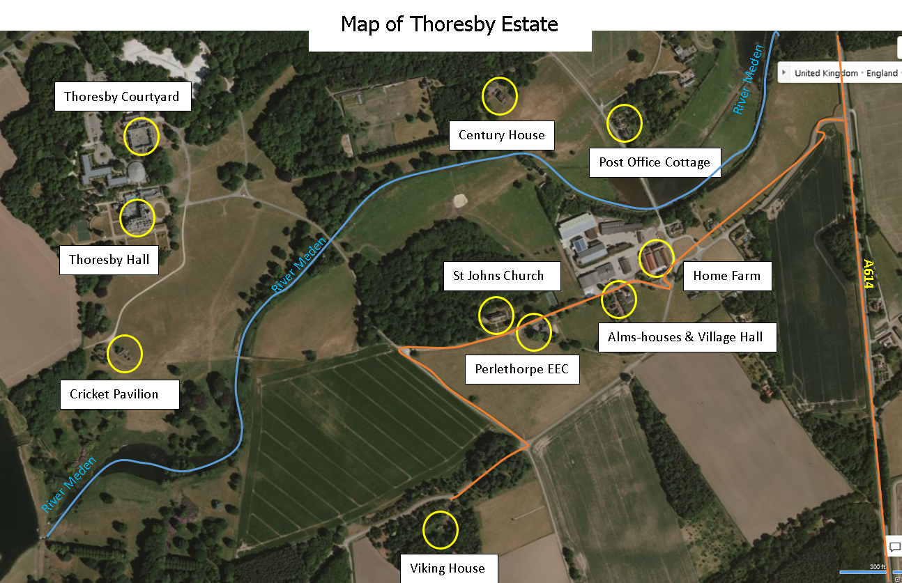

Safety Procedures at the Centre

Notes for Leaders

Fire Procedures

1. All staff should be aware at all times that a fire could occur. All pupils and adults should be briefed at the start of the visit re fire procedures and the location of fire alarms, extinguishers and exits. Fire procedure and assembly points are displayed in all rooms.

2. An emergency roll call list must be kept with the visiting staff member at all times.

3. On discovery of a fire, the alarm should be raised immediately (by voice, bell or alarm system according to individual centre’s provision).

4. The fire service should be called by dialling 999 and stating the address of the centre.

5. The teacher in charge of the group checks all rooms are clear (including toilets and storage areas). Other adults should lead pupils to the assembly area. All of the group are to assemble in the areas designated (see signs in each centre) and a roll call completed. No one should re-enter the building until declared safe by the emergency services.

6. If there is an opportunity to fight the fire, extinguishers in the building should be used. Ensure the correct extinguisher is used for each type of fire. No one may re-enter the building unless authorised to do so by a fire officer.

Medical Information and First Aid Arrangements

1. All day centre teaching staff have current first aid certificates.

2. Relevant medical details of pupils and staff should be brought to the centre along with the register of those on site. Visiting teachers should make appropriate arrangements for the storage and administration of prescribed drugs and inform centre staff of any relevant medical conditions of staff or pupils.

3. Schools should bring their own first aid equipment for their group’s use on the journey and on site. However, first aid equipment is located in each centre and leaders should familiarise themselves with its location. Items used from the kits should be reported to the centre staff in order that they may be replaced.

4. ‘Teacher safety packs’ are available at each centre for schools’ use while on site. The contents include first aid kits, whistle, spare clothing, sterile water, maps of the site and location of nearest hospital, and emergency blankets.

Local doctors’ numbers:

Middleton Lodge Surgery, New Ollerton
Telephone: 01623 703266

5. It is recommended that a mobile phone is carried when groups are working away from the centres. Make sure a signal is obtainable.

6. A trained first aider should accompany each school class on site.

7. If your school is planning studies in water, please read the advice in relation to Weil’s disease.

8. In the event of a serious emergency requiring medical treatment, leaders should call the ambulance service on 999. Any pupil transported to hospital must be accompanied by an adult.

9. Ambulance access: in the event of an accident at Perlethorpe, a competent adult must meet the ambulance at Home Farm (farm archway) and direct them to the location needed.

Recording and Reporting of Accidents, Illness or ‘Near Miss’ Incidents

1. Any significant accident or illness should be reported in the accident/near miss logbook at the centre. Accidents or illnesses requiring a visit to the doctor or hospital should be recorded on an SR3/5 form. A copy of this form should be left with or sent to the centre as soon as possible after the incident.

2. If an accident requires anyone to be taken to hospital, the Health and Safety Executive must be notified within 24 hours.

3. Any incident which does not get recorded as above, but in the opinion of centre staff or visiting staff could have resulted in injury or illness, should be considered as a near miss. Near miss incidents should be recorded in the logbook. These will help minimise future accidents.

4. All SR3/5 forms should be reviewed once a term by the Head of Day Centres and relevant day centre staff.

5. It is the school staff’s responsibility to store and record the administration of such prescribed drugs.

Weather Forecasts (and water levels for activities by or in water)

• During all outdoor activities, a daily weather forecast must be noted and the day’s plans reviewed in the light of the forecast and prevailing conditions. Under certain conditions, a change of plan may be needed. Centre staff will be able to advice on this matter.

Food Hygiene

Pupils must always wash their hands thoroughly with soap and running water before eating lunch. An adult must supervise hand washing. Do not allow pupils to consume food or drink while taking part in an activity. If a picnic lunch is planned away from the centre, arrangements will need to be made for pupils to wash their hands. This is especially important after river activities.

Road Safety

Although many of the roads and tracks at the centres are quiet, they are used by a variety of vehicles including farm and industrial vehicles. Care must be taken at all times when crossing roads and pupils must always be supervised.

Outdoor Conditions

Schools must ensure that the group is suitably protected, clothed and correct footwear for the expected weather conditions.

In particularly hot weather please protect pupils’ heads, necks and shoulders and children should bring their own sun lotion

Insurance

The insurance position is as explained in Nottinghamshire LA’s ‘Visits Guidance for Children and Young People’. Teachers are covered by the Council’s standard insurance for staff during visits, INSET meetings and pre-arranged planning meetings, but this provides no cover for teachers’ personal belongings and no cover for pupils. Schools can arrange school travel insurance or personal insurance for teachers through the County Council’s insurance section (telephone 0115977 3331).

Activity Codes of Practice

The pages which follow provide guidelines on the undertaking of activities at the Environmental Education Day Centres: Perlethorpe. All activities at the centre must be undertaken according to these guidelines.

Risk Assessments

These codes of practice are formed alongside the centre risk assessments of the sites and activities. If you wish to view these risk assessments on the internet, visit
www.nottinghamshire.gov.uk/nottsoutdoors and go to the website for the centre you are visiting. However, for planning and leading activities it is more important that leaders familiarise themselves with these codes of practice than the risk assessments. Schools should also refer to their LA’s generic risk assessments and their school’s specific risk assessments for these types of visits. If necessary, the visit leader and Educational Visits Coordinator may need to complete a specific risk assessment for their visit to the centre, particularly if there are some pupils with special needs in the group.

Group Sizes and Staffing Ratios

The whole group must be led by a qualified teacher. It is expected that each separate working group will be under the supervision of a qualified teacher. Head teachers may, however, decide that other members of school staff may fulfil this role. Parents and other adults significantly contribute to good supervision and adult/pupil ratios. It is expected that groups will operate in ratios of not greater than one adult to 10 pupils, though with younger and special needs pupils and for certain activities ratios of 1:6 or less are recommended.

Personal equipment

In wet, cold and muddy conditions, boots or wellingtons are strongly advised additional warm clothes (depending on the weather conditions), waterproofs, hats and gloves brought if required. Full length trousers are recommended when walking in woodland or scrub areas, or in areas where deer and sheep are present. (Small ticks can carry Lyme Disease). Medication/asthma inhalers, epi pens, sun creams etc. where necessary. In hot/sunny weather, pupils will need a sun hat, sun cream and a long sleeved top to cover up.

Group equipment

Teacher safety rucksack containing first aid kit Mobile phone/radio (if available) Maps, compass (if needed), whistle Throwing line if walking near water

General considerations for visits to all centres

Discuss with pupils beforehand awareness of and consideration for other groups, such as horse riders or dog walkers. Follow the Country Code; discuss it with group before the visit. Take extra care on country roads. Walk on the right-hand side of the road, with an adult on the road side, and stand still when traffic approaches together on one side of the road.

Inform pupils of possible hazards during visit Follow agreed access arrangements closely and adhere to any special circumstances or warning notices (e.g., no access to deer parks during rut in October/November).

Routes should be planned to take into account the prevailing weather conditions and altered on the day if necessary. For example, a walk-through woodland could be hazardous and therefore inadvisable during extreme windy conditions.

Female visitors to farms should be advised there is a possible risk of diseases being transmitted to pregnant women in contact with pregnant sheep and goats.

Hands must be washed thoroughly before eating with running water and soap, under adult supervision.

Other visitors to sites/general public may be in areas used by schools. Pupils need to be aware of this and how to behave.

Be aware of barbed wire and electric fences on all sites.

At lunch times pupils are supervised by visiting school staff/parents. There should be a first aider with the group and activities the children engage in should be suitable to the terrain and weather conditions.

Watch out for tractors and other farm traffic at Perlethorpe.

When using the Anderson Shelter at Perlethorpe (on Evacuee Days) a safety talk
on the correct access and exit procedure should be given before entering and warn pupils of uneven floor and low roof. A maximum of 15 pupils in the shelter at any time at Perlethorpe.

Weil’s Disease

Weil’s disease (or leptospirosis icterohaemorrhagiae) is an infection caused by bacteria carried in rats’ urine, which contaminates water and wet riverbanks. The bacteria does not survive long in dry conditions. The likelihood of becoming infected is greater from stagnant or slow-moving waterways, where rats are present.

Weil’s disease is rare, but it can be a serious illness requiring hospital treatment and can lead to kidney or liver failure. The disease is a notifiable illness.

It is caught by absorbing the bacteria through the skin and the mucous membranes of the mouth and eyes. The bacteria gets into the bloodstream more easily through a cut on skin.

Should anyone fall ill with the symptoms after contact with infected water, particularly within a period of 3-19 days, they should see their doctor immediately. The most common symptoms are: temperature, an influenza-like illness, and joint and muscle pains. Tell the doctor you have been in water and where. It is important that antibiotics are administered straight away if there is any chance of having contracted Weil’s disease. A blood test is usually taken to confirm the illness. Doctors can obtain advice and more information about the disease from the Leptospirosis Unit, Hereford Hospital on 01432 818822.

Preventative action to take

1. Cover open scratches or wounds with waterproof plasters before arriving at the centre. Bring plastic/rubber gloves for any pupils with such scratches to wear during the water activity.

2. Always use suitable footwear to avoid cutting feet.

3. Wash hands after contact with streams or ponds.

4. Tell all pupils and parents that Weil’s disease is rare. However, if they have a flu-like illness up to 19 days after the visit to go to their GP and tell him/her that they have been in contact with water and could possibly have contracted Weil’s disease.

Lyme Disease

Advice for school staff, parents & carers

Ticks are small, spiker-like creatures that feed on the blood of animals, including people. The size of the tick can vary, with a larva being as small as a tiny freckle, and fully fed females similar in size to a baked bean.

Ticks survive in many habitats but prefer moist areas with leaf and litter or longer grass, like in woodland, grassland, moorland, heathland and some urban parks and gardens. Ticks don’t fly or jump. They wait on vegetation for a host to pass by, and then climb on. They bite and attach to the skin and feed on blood for several days, before dropping off. Ticks are found throughout the year but are most active between spring and autumn.

Main health risks
- ticks can sometimes transmit microbes that may cause human diseases such as Lyme disease. It is important to be Lyme disease aware and see your GP promptly for diagnosis and treatment if you recognise the symptoms which include:
- a flu-like illness, fatigue and muscle and joint pain
- a characteristic expanding red rash, erythema migrams (may be present but not all cases)
- you may not always remember being bitten by a tick, so if you have spent time outdoors and develop any of these symptoms, seek advice from you GP or dial NHS 111.
- lyme disease can be treated with a course of antibiotics. Without treatment, more serious conditions can develop such as swelling in some joints or problems with the nerves and heart, so prevention and early detection are key.

Prevention action to take
- walk on clearly defined paths to avoid brushing against vegetation
- wear light-coloured clothes so ticks can be spotted and brushed off
- use repellents such as DEET
- carry out a tick check

If you have been bitten
- remove ticks as soon as possible
- the safest way to remove a tick is to use a pair of fine-tipped tweezers or a tick removal tool
- grasp the tick as close to the skin as possible
- pull upwards slowly and firmly, as mouthparts left in skin can cause a local infection
- clean the bite area, and monitor it for several weeks for any changes
- contact you GP promptly if you begin to feel unwell with flu-like symptoms or develop a spreading circular red rash. Remember to tell them you were bitten by a tick or have recently spent time outdoors.

More information
For more information, search for the phrases ‘ticks’ and ‘Lyme disease’ on these websites: www.nhs.uk and www.gov.uk

Activities

Location
On centre site or in surrounding woods, fields etc.

Leader in charge
Experienced visiting teacher or centre staff, with appropriate qualifications for activity

Recommended group size/staffing ratios
These are dependent on activity and can be discussed with the Outdoor Tutor

Equipment for the Visit
Clothing to suit weather and time of year, medication to be carried at all times. Mobile phone / radio (if available), safety pack / first aid kit

Other considerations
Before setting out run through the safety checklist:
• Don’t touch/eat fungi or berries.
• Vehicles (Tractors, Cars, Lorries) – stand to one side of the road.
• Dogs/horses – do not approach them, stand still and quiet.
• Children who use asthma inhalers, epi pens should have them at all times.
• Do not run-down hills.
• Stay together in pairs/small groups.
• if Shelter Building Do not use sporing bracken during late July/August as spores are considered a health risk
• If members of the public are bothering groups, return to base & consult teacher.

T 0115 977 1234
E another@nottscc.gov.uk
W www.nottinghamshire.gov.uk
Department, Address line Postcode
D&P/05.12/
Adventure Base, Kings Mill Road East,
Sutton in Ashfield, NotNG17 4PA
T 01623 822218
E Perlethorpe@nottscc.gov.uk
W www.nottinghamshire.gov.uk/outdooreducation
Outdoor and Environmental Education Centre, Environmental Education Centre,
New22 9EQ
T: 01623 822218
E: Perlethorpe@nottscc.gov.uk
W: www.nottinghamshire.gov.uk/outdooreducation
Outdoor and Environmental Education Centre, Perlethorpe Environmental Education Centre, Perlethorpe, Newark Notts. NG22 9EQ.

