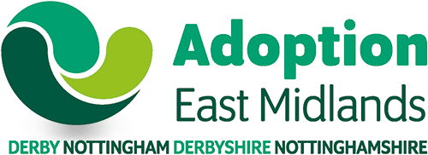

Recruitment Strategy Adoption East Midlands Regional Adoption Agency Updated: April 2026

Overall Objective
Adoption East Midlands seeks to meet the need to place the children of Derby, Nottingham, Derbyshire and Nottinghamshire who have an adoption plan with adoptive families, who can meet their needs throughout childhood, including the additional needs of children who have suffered childhood trauma. The aspiration for Adoption East Midlands is that we place at least 80% of our children with Adoption East Midlands adopters. We aim to have choice for children via a pool of adopters.

Numbers of Children
Adoption East Midlands expects to be asked to find adoptive families for approximately 130 children a year. Adoption East Midlands also expects to support these children and their families, throughout childhood and into adulthood, as needed.
Adoption East Midlands where possible will seek to place children within the geographical boundary of Derbyshire and Nottinghamshire.
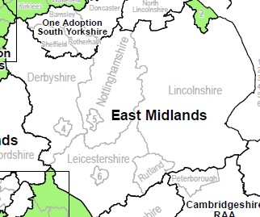

Adoption East Midlands feels confident there is a robust support offer within the region.

Sufficiency
It is expected that Adoption East Midlands will not provide enough adoptive families for all the children, and that for some children, the right match may not be available within Adoption East Midlands families. Then AEM will work with partner RAAs across the Midlands, and nationally, and with VAAs to place children.

Adoption East Midlands aims to recruit at least 90 families per annum, which would meet 80% sufficiency and leave approximately 30 children who would be placed by other agencies.
However, where there are large numbers of single children within the 130, more families are needed, in 25/26 there were 100 single children.
A small number of AEM families will match with children from other RAAs in the Midlands, or nationally, if the right match is not available to them within AEM.

Currently AEM do not have enough adopters and are only able to place around 60% of the children with AEM adopters.

Recently, less than a fifth of the children AEM place, are in sibling groups,
Two thirds are single children, under the age of two,
One sixth are aged over 5 years old.
One fifth are not white British, and of these, most children have a mixed ethnicity.

Methods used to identify matches:
- Linkmaker
- Homefinding meetings, inviting regional RAA partners.
- Regional Profile exchange with Regional Adoption Agencies; and VAAs
- Local profile events organised by Adoption East Midlands.
- Adoption Activity Days.
- Possible use of Local activity events e.g., stay and play.
- Tracking of children to ensure sufficiency of adopters and identify any significant themes.

All Adoption East Midlands adopters are placed on Link Maker under Adoption East Midlands parameters. During assessment of adopters there is a strong and consistent message re the benefits of Adoption East Midlands adopters adopting Adoption East Midlands children, there are 130-150 children needing adoptive homes in any one year.

Currently AEM needs more adopters, all applicants are taken through the preparation process, as quickly as is possible.
If Adoption East Midlands has adopters waiting 3 months after approval, or earlier dependent on family's needs, or a family wishes to consider children from other areas, Adoption East Midlands will support families to identify children. A family finding member of staff may be asked to support adopters with this.

Adoption East Midlands Adopter Recruitment
- National Adopter recruitment campaign
- Annual recruitment activity plan
- Ongoing Recruitment and Social Media Marketing strategy throughout the year
- Website.
- Local publicity campaigns.
- Adoption Awareness Integrated digital and community- focused campaign
- Regional publicity campaigns. (Midlands)
- Instagram and Facebook campaigns/posts
- Media statements.
- Dedicated recruitment Staff at local community events such as PRIDE, Carnival, cultural festivals, county show
- Staff at Pop-up events at local places, such as supermarkets, shopping centres and leisure centres
- Staff at local community groups, including LGBTQIA+ groups, faith organisations, health providers, and community radio stations.
- Adoption Community Events specifically reaching out to Black and mixed heritage families
- Experienced adopters also at events, and information events, and plans to include a peer role, to keep in touch with prospective adopters.
- Develop the peer network, to act as adoption ambassadors.
- Develop specific recruitment Strategies for Black Adopters and LGBTQIA+ families

Recruitment Principles
Adoption East Midlands will accept applications from:
- Single people, and couples, same sex or mixed.
- There is no upper age limit, but adopters must be over 21.
- Homeowners, or tenants.
- People who already have children – we will discuss the recommended age gap with you.
- People living within the Derbyshire and Nottinghamshire Boundary.
- People outside this boundary where that meets the needs of waiting children.
- People in employment or unemployment.
- People with disabilities.

Adoption East Midlands will particularly welcome applicants who can consider:

- Black Children, mixed heritage children and children from Eastern European backgrounds.
- Brothers and sisters
- Older children.
- Children with complex health needs.
- Children with uncertainty, or developmental delay.

Early Permanence

Once applicants are approved as adopters, it is possible to place children as fostered children, thus enabling children to be placed much earlier, and have less changes of carers. AEM encourage all adopters to consider this and wish to increase the number of children placed this way, last year 25 placements were made this way.

Preparation
Adoption East Midlands offers a comprehensive preparation offer during Stage One and Stage two. In addition, to support the needs of children, seminars regarding early permanence (foster for adoption), Parenting brothers and sisters, Linking, Matching and Transitions and moving in, therapeutic parenting are offered. We have Coming Home Sessions, delivered by Peer Mentors. We use Virtual Reality headsets as an additional resource to assist understanding of attachment and trauma and for applicants who wish to adopt siblings.

Course content is regularly reviewed and updated to ensure it reflects current research, evolving practice and the diverse needs of applicants.

We also offer a year’s membership to prospective adopters for CATCH –

Children and Trauma Community Hub
In addition, we have our ‘Peers4Peers’ network; a regional community of experienced adopters, led by experienced adopters in post, who support preparation training as well as providing the opportunity for local and regional community networking, support and 1:1 mentoring.

Children currently waiting for placements are, brothers and sisters, single children over the age of four ??? Now two, children of mixed ethnicity, and children with developmental uncertainty or additional needs.

Approved adopters are usually linked with children very quickly.

Adoption Support
AEM provide a range of services for adoptive families, adopted adults and birth families, designed to offer the right level of support at the right time throughout their individual adoption journey.
Many adopted children need help to navigate different points in their life, whether in their early years, at adolescence or as young adults. Adoptive Parents may also find that at times some guidance and support is needed at different points throughout their child’s development.
At AEM we want to make sure that families can access the right support at the right time whether that be during preparation to become adoptive parents, in the early days of becoming an adoptive parent or at key points during a child’s development as they come to terms with what it means to be adopted. Our aim therefore, is to:

- Work in co-production with adopters and adoptees to understand their lived experience, what support can make a difference and the ongoing development and delivery of our regional support offer
- Always ensure that children and young people are seen, heard and enabled to share their own needs, wishes and feelings
- Provide informed and timely multi-disciplinary support for adoptive families and their professional network from the start of their adoption journey and through all stages of development post order which is focused on early intervention and improved outcomes
- Deliver excellent customer service which is proportionate to the level of need and with the aim of empowering families and improving outcomes for all
- support adopted adults and birth relatives with a clear service pathway
Our core support offer includes:

- Providing Information, resources and guidance (Adopters' Support Hub Nottinghamshire County Council)
- Signposting to relevant and helpful groups and organisations
- Providing regular & relevant training seminars and access to peer support
- Providing an easily accessible early support offer from our multi-disciplinary reflecting team which includes specialist consultation
- Access to and delivery of therapeutic services and support programmes (group and 1:1) utilising the Adoption Support Fund where necessary
- Multi-disciplinary adoption support needs assessments, and support planning
- Delivering packages of therapeutic / parenting support to families using our in-house therapists (including DDP, Systemic Family Practice, Theraplay and Therapeutic Life Story Work)
- Helping families keep in touch with people who are important to their child, and restring links at the adoptive families request where possible
- Providing Birth Family Support to enable more effective and better supported keeping in touch arrangements

At AEM we believe that co-production with experts by experience helps develop more equal partnerships between families who use our services and professionals, and can help make the best use of resources, deliver better outcomes for adoptive families and build stronger relationships and communities across our region. We now have a number of co-production groups who meet regularly to review and develop our support offer including:

These groups are a collaborative space where people come together as equals to talk about issues and create services that work for everyone involved whilst providing mutual support along the way. Groups have been established around key areas of support need:
- - Parents together in adoption (formerly the Complex trauma group)
- Parents of Teenagers
- Education

These groups are now embedded in the AEM service offer with two Peer Network Co-ordinators employed and will continue to run to ensure the ‘lived experience’ is at the forefront of our service delivery model.

In addition, this year we have established our first Young People’s Voice & Influence Participation Strategy for the region. Using a youth work approach, our aim is to strengthen youth voice and participation for adopted young people across the East Midlands. It builds on our existing Voice of Adoption framework and our Youth Connect offer (group support), expanding opportunities for engagement, consultation, and co-production and developing regional and national representation opportunities for our young people. Groups include include:
- Young People’s activities programme; tailored to different age groups and including a SEND specific group
- Voices of Adoption (Junior and Senior and Young adults) create spaces for young people to come together to discuss adoption related issues from their perspective and co-design services. As well as providing a space for peer support and relationship building, the Voices groups pilot activities proposed for young people’s events and provide consultation to the service and national forums such as Adoption England and the Department for Education. The group is part of the national “Voice & Influence” forum giving young people a say in influencing adoption services nationally.
- Youth Connect Group offer - We have a comprehensive youth offer, developed in consultation with young people; this year we have added to our Youth forums and Youth Connect Club by introducing two new opportunities for young people to come together:
- Our Base Connect Youth Group offers an inclusive group for young people who are currently receiving less than 25hours of education per week or home schooled and;
- Our Gen Connect Youth Group has been designed specifically for young people aged 11-18 whose gender identity differs from the one assigned at birth and offers support whether in the early stages of questioning their gender, actively exploring what it means to them, or enabling a confident affirming of their identity, Gen-Connect is a space where young people can feel seen, heard and supported.

Our online Adoption Support Hub is easily accessible and contains information, guidance, resources, and links to other support organizations. A great first port of call for support which includes news alerts and regular updates of interest and a link to sign up to our monthly newsletter. www.adoptioneastmidlands.org.uk/adopters

Multi-disciplinary support:
At AEM we adopt a systemic approach to adoption support using a neuro-sequential lens which is focused on early intervention and underpinned by our regional Peer Mentor community. Our core and early intervention support offer is used to support regulation, feelings of safety and stronger relationships between young people and their main care givers, as well as looking at the wider system of interaction and support around a young person.

Now fully integrated into our wider social work team is our multi-disciplinary team (MDT) which incorporates specialist, trauma informed knowledge & practitioners from education, health, youth work, therapeutic social work and representatives from the adoption community. These roles within the MDT enable a more holistic understanding of need and therefore the most effective support at any given time.

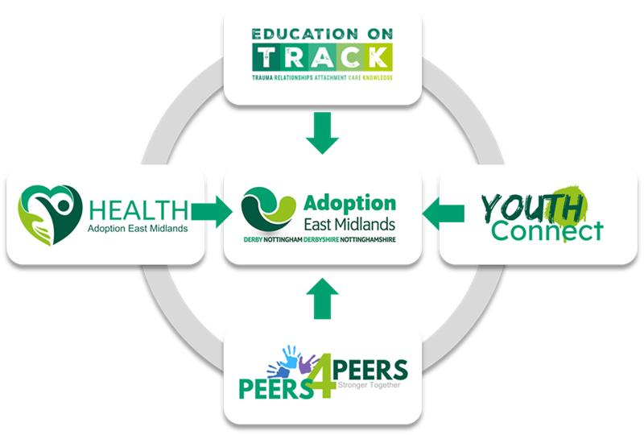

Through our multi-disciplinary reflecting team, we seek to work alongside parents to bring crisis levels down, increase resources for the family (both internal and external to the family) and promote feelings of safety for the whole family. We do this by:

- Understanding the child’s history & developmental trauma through multiple lenses enabled through our MDT approach
- Stabilising the child’s home and school environment so they are able to better regulate
- Provide support to primary care givers to strengthen their network (this can include family, friends, informal and formal support) to create feelings of safety
- Providing resources, training, consultation and support to educational staff to better understand and support the needs of adopted young people in the school environment
- Provide consultations to families and professionals giving opportunities for deeper reflection, understanding and planning.

Helpdesk
Our team of therapeutic helpdesk social workers are part of the multidisciplinary reflecting team that triages incoming pathway referrals from families and are the first point of contact for families into the service. Having background information already supplied by the family and including the voice of the child where possible means that when they make contact, our social workers are immediately able to start to support families through therapeutic listening & reflection. Our Helpdesk team will hold and support families for up to 8 weeks and this will include visiting the family and the young person at home to inform their holistic understanding of need and put appropriate early intervention support in place.

Adoption Assessment & Support
Where difficulties are more challenging, sustained or complex, families can be referred into our holistic team of specialist social workers who will facilitate a multi-disciplinary assessment of need and support plan, working with families (including direct work with young people) for up to 20 weeks. If more specialist therapeutic support is identified as a need, our social workers can commission a therapy package from our in-house therapists or via our therapeutic providers commissioning framework.

Shelagh Mitchell
Head of Service, Adoption East Midlands

Lisa Drummond
Service Manager, Adoption East Midlands

Jane Bolan
Service manager Adoption East Midlands

May 2026


working together


